

Radboudumc

Radiotherapy Department

sqlite4radiomics

Software User Manual

Table of Contents

1. Program requirement 2

1.1 Knowledge requirements 2

2. Program Overview 3

2.1 The Interface 3

2.1.1 Main page 3

2.1.2 Help 5

2.1.3 Menu 6

2.1.4 Modify file contents 6

2.1.5 Recalculate and message area 7

2.1.6 Change region of interest priority 7

2.1.7 Re-initialize tables 8

2.1.8 Delete calculation calendar 8

2.2 Configuration File 9

2.3 Parameter File 10

2.4 Conquest Pipeline Trigger 10

3. Setup 12

3.1 Python 12

3.2 NodeJs 12

3.2 The zip file 12

3.3 Setting up 13

3.4 Data 13

4. Operation 14

4.1 Terminal 14

4.2 Interface Layout 16

5. Troubleshooting 20

5.1 Python 2 20

5.2 Terminal Errors 20

5.3 CSV and Logs 20

# 1. Program requirement

**SQLite4Radiomics** was originally written for Windows 10 platform. It should in principle, also work on windows 7/8/8.1. Other platforms are not fully supported.

**Python** and **NodeJS** are required to run this software tool.

**It is advised that you read through this document in its entirety before running the tool.**

## 1.1 Knowledge requirements

The user should have some experience with working with **Radiomics**.

It is recommended that the user read about **Pyradiomics**. This will help to understand how the parameters work and how they can be used. This will also help understand how to use and modify the parameter file – refer to <https://pyradiomics.readthedocs.io/en/latest/customization.html>

Once you have read this, you are better equipped to modify the **Parameter file** according to your needs.

# 2. Program Overview

## 2.1 The Interface

### 2.1.1 Main page

Here we can see what the application looks like when it is first opened. This is the main page. As there is no table selected, no data can be seen in the table.

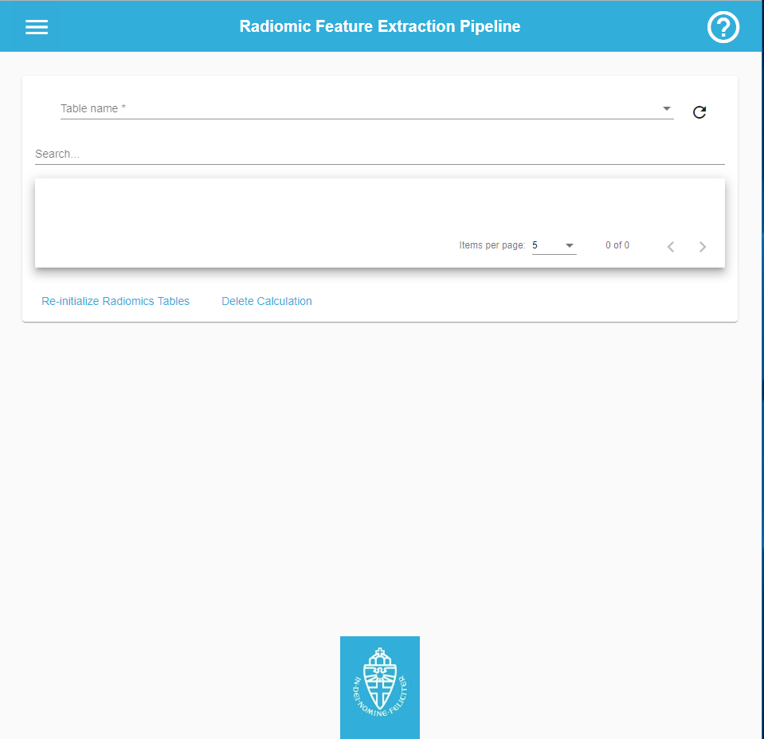

The user can then pick a table name from the dropdown.

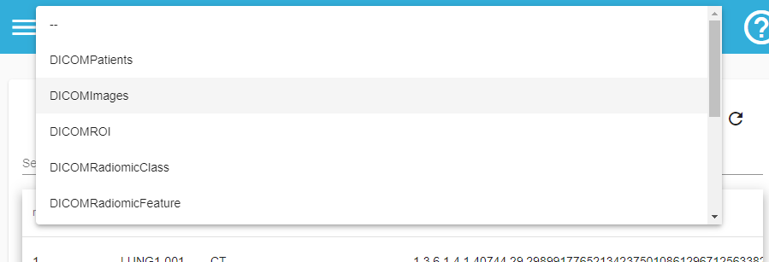

After selecting a table, the corresponding data will be loaded in.

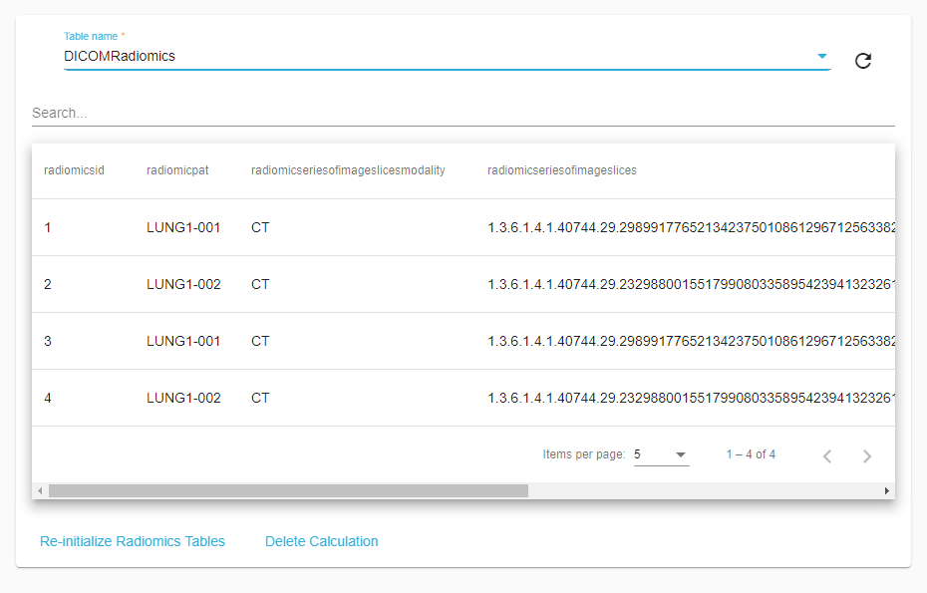

From here a user can search for particular information, sort the columns, or even change how many rows to view at a time.

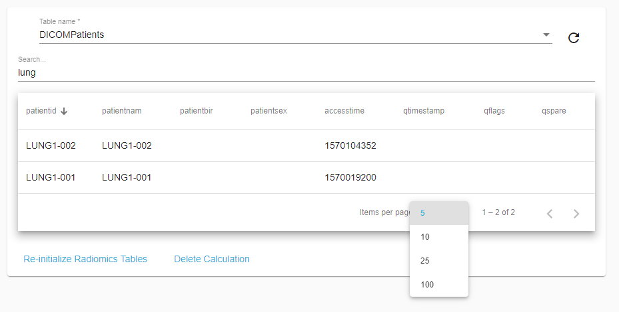

A user can also refresh the information on the table they are currently viewing by using the refresh button.

### 2.1.2 Help

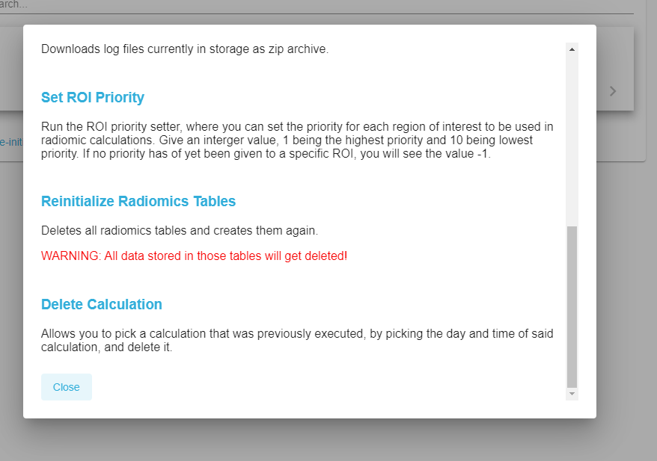

If the user clicks the Help icon (question mark inside circle), this dialog will appear, explaining what each option in the application does.

### 2.1.3 Menu

  
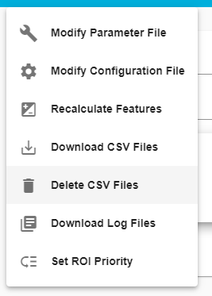If a user clicks on the menu icon (three stripes), the options seen are available.

**Download** options will automatically download the specified file/s.

Clicking on the file modification options (for parameter or configuration files), will load the file’s content for editing.

The **delete** option will delete all outputted csv files.

### 2.1.4 Modify file contents

Clicking on the file modification options (for parameter or configuration files), will load the file’s content for editing.

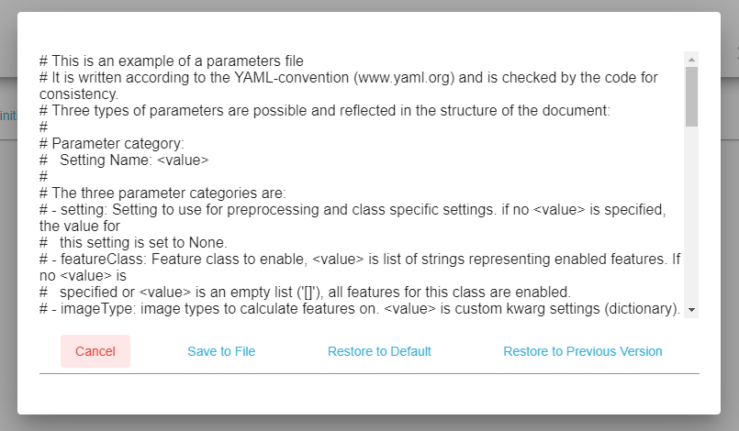

The user can then modify the file and save, cancel, restore to the default file or to the most recently stored version ( example: file was modified and saved, then it was modified again and saved, if you then restore to previous version, it will set the file contents to match the modification previous to your latest one). It only keeps track of one previous modification to the current file contents.

### 2.1.5 Recalculate and message area

When choosing the recalculate option, a message area will appear with information on the calculation process.

Cancelling will issue a cancel request. This will tell the application to finish the current calculation, but to then finish and not calculate any further.

### 2.1.6 Change region of interest priority

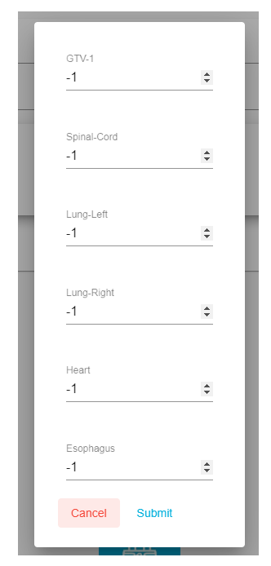

For the ROI priority setter, it allows for the values to be changed and saved from the interface.

### 2.1.7 Re-initialize tables

If the user selects the Re-initialize Radiomics Tables option from the main page, the following will appear:

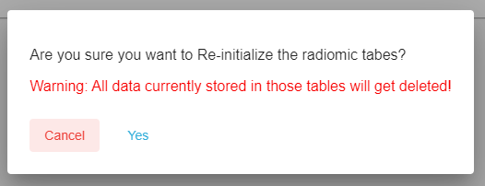

The user will be confronted with a warning. If the user clicks the ‘Yes’ option, the radiomics tables and data within will get deleted. The tables will then be created again.

### 2.1.8 Delete calculation calendar

Selecting the Delete Calculation option will open a calendar with specific dates highlighted where calculations were made.

If the user clicks on a highlighted date (orange), the calculations done that day will appear as selectable options.

Once a user has decided which options to delete, clicking the Delete button will permanently delete them from the database.

The delete calculation displays calculations per parameters used (see below).

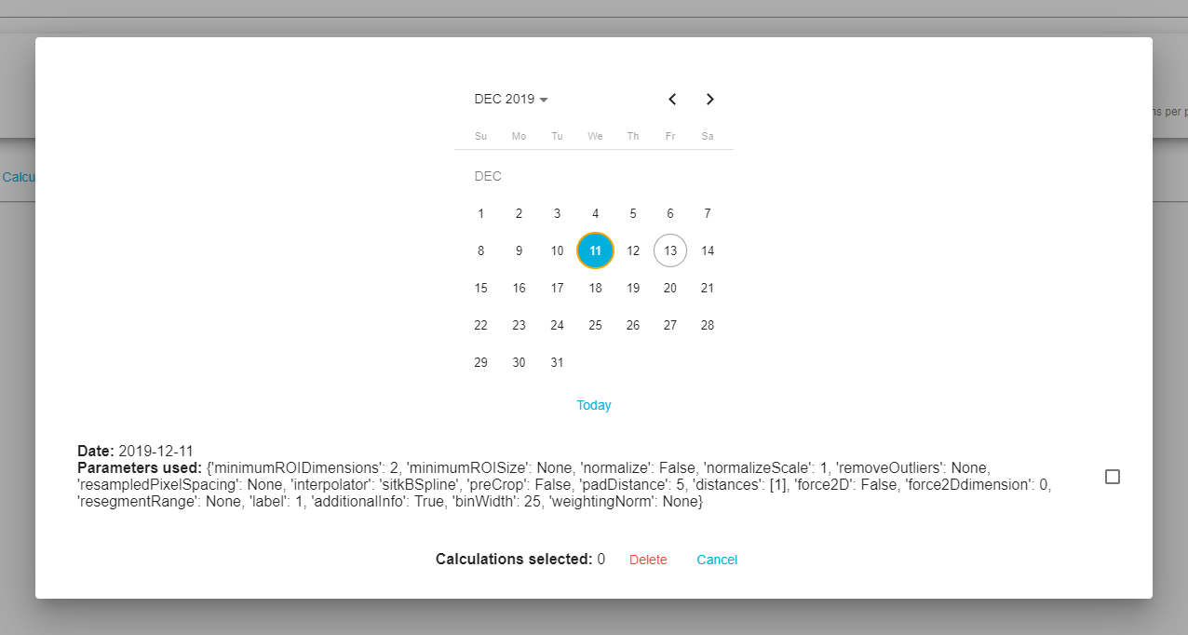

## 2.2 Configuration File

When running the tool, you can edit the configuration file’s contents. Below is a preview of what this file looks like (slightly different styling when edited from within the tool’s user interface).

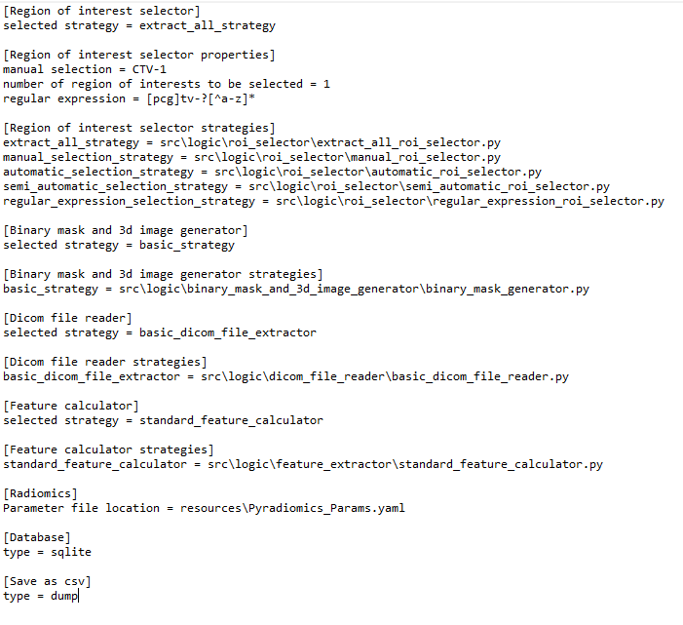

**Region of interest selector –** section where the Region of Interest (ROI) selection strategy is specified. the list of possible strategies can be found in the **Region of interest selector strategies** section. Change the value of the selected strategy on the right side of the “=” to one of the ones found in **Region of interest selector strategies** section to switch between these strategies.

* **extract_all_strategy -** extracts all ROIs
* **manual_selection_strategy -** extract only specific ROIs added to the *manual selection*, under the **Region of interest selector properties**
* **automatic_selection_strategy –** extracts specific number of ROIs based on the value specified in number of *regions of interest to be selected* under **Region of interest selector properties**. Goes through all ROIs and checks their priority, extracting only the first *n* ROIs starting from the highest priority.
* **semi_automatic_selection_strategy –** works similarly to automatic, but also extracts any ROIs specified manually.
* **regular_expression_selection_strategy -** uses a regular expression specified in *regular expression* under **Region of interest selector properties**. The default expression looks for ROIs that have a name related to GTV (gross tumour volume), PTV (planning target volume) or CTV (clinical target volume).

**Save as CSV –** section where you can specify how you want feature extraction data to be saved:

* “dump” will append all calculations one single csv file.
* “individual” will separate data per patient and modality and save it separately, appending only new calculations performed to the same patient and modality to those files.

Other sections are of this file are for advanced usage. **Only modify** **if you** **know what you are doing**.

## 2.3 Parameter File

The parameter file is used to customize the feature extraction process. To modify this file, it is recommended that the user refer to the Knowledge Requirements in section 1 of this document before proceeding.

## 2.4 Conquest Pipeline Trigger

The tool always checks for uncalculated RTStruct on startup. If uncalculated data is found, the pipeline is triggered, and the calculation process is started. Depending on the ROI strategy selected, some RTStruct might be ignored, and therefore trigger this check every time you start the interface.

If you want to add a small amount of new data, such as a couple of new DICOM files, there is the option of toggling on a trigger in Conquest. This can be helpful when you have already have an optimal configuration and there is only few data to be added. This would make the process automatic and not require the tool to run to get new calculated data.

In the next page you can see how this file looks like.

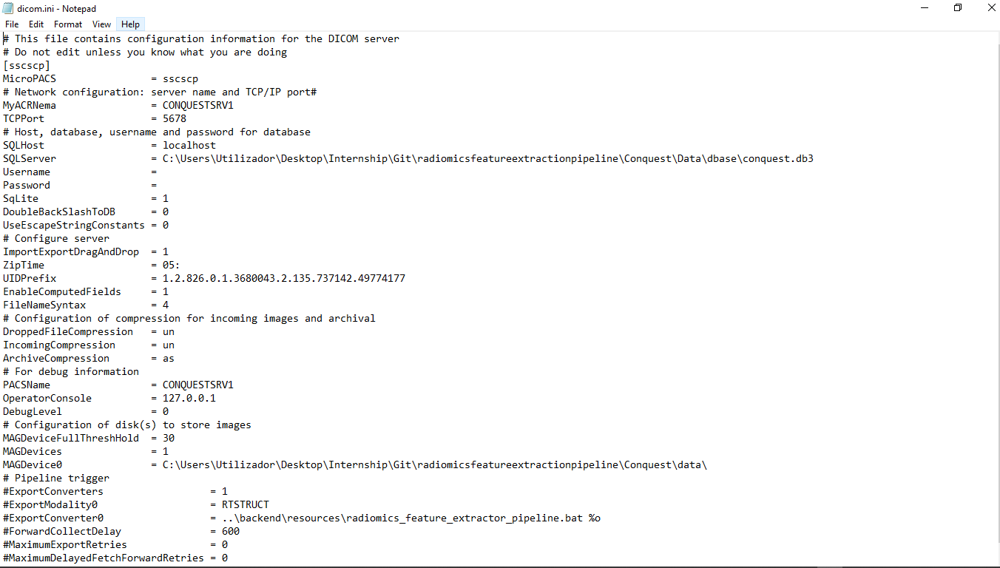

Remove the #’s from the highlighted lines and save the file to toggle the trigger. Add these back in and save the file to toggle off the trigger.



WARNING: Do not use for big amounts of data! This trigger will open a separate terminal window per every new RTStruct stored by Conquest!

# 3. Setup

## 3.1 Python

Go to <https://www.python.org/downloads/release/python-365/> and download the appropriate installer for your system.

Follow the necessary steps to install python 3.6.5

Make sure that you choose the option during installation to add python to the Path.

## 3.2 NodeJs

Go to <https://nodejs.org/en/> and download the appropriate installer for your system.

Follow the necessary steps to install NodeJs

## 3.2 The zip file

Unzip the provided file and place it anywhere you would like. Keep the original zip file in the case of needing a second Conquest version to store a different dataset.



WARNING: Do not move any of the files or folders found within the unzipped folder!

Inside the main folder:

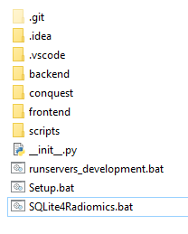

Conquest folder, where Conquest installation is located

File used for performing the setup

File used to run the tool

Other files are used for development and should be left alone unless you know what you are doing.



WARNING: Modifying or moving any files could cause the tool to stop working!

Conquest folder:

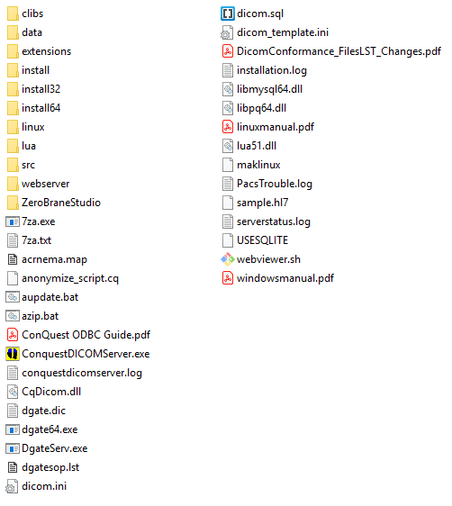

Folder that contains the dataset files and database file

File to execute Conquest

File with configurations for Conquest

## 3.3 Setting up

Run the ***Setup.bat*** file. This will make sure that:

* the paths that Conquest uses, matches the current location on your machine
* creates the necessary virtual environment and installs the necessary python packages
* installs necessary node packages

You should see a command prompt window pop up and go through the installation of the necessary packages.

If when running this file, the command prompt window immediately closes after execution (no package installation could be seen), then refer to the Troubleshooting section.

## 3.4 Data

Go to the ***conquest*** folder and run ***ConquestDICOMServer.exe***

When Conquest is running, go to the ***data*** folder and open the ***incoming*** folder within. Drop your DICOM files here while Conquest is running.

# 4. Operation

Run the ***Sqlite4Radiomics.bat*** file to start up the tool.

## 4.1 Terminal

This is what the terminal will look like when starting the tool.

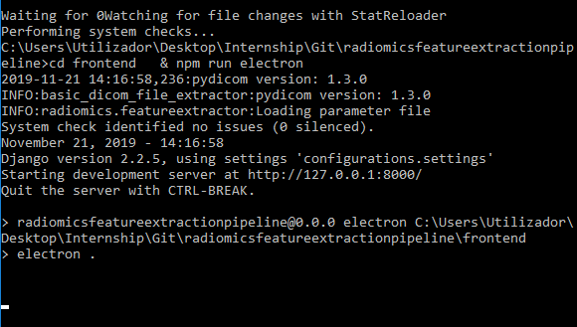

The terminal is what the user first sees when executing the application. This terminal is always running, even when the interface is visible, and shows logging information.

In the next page is an example of the terminal during feature extraction.

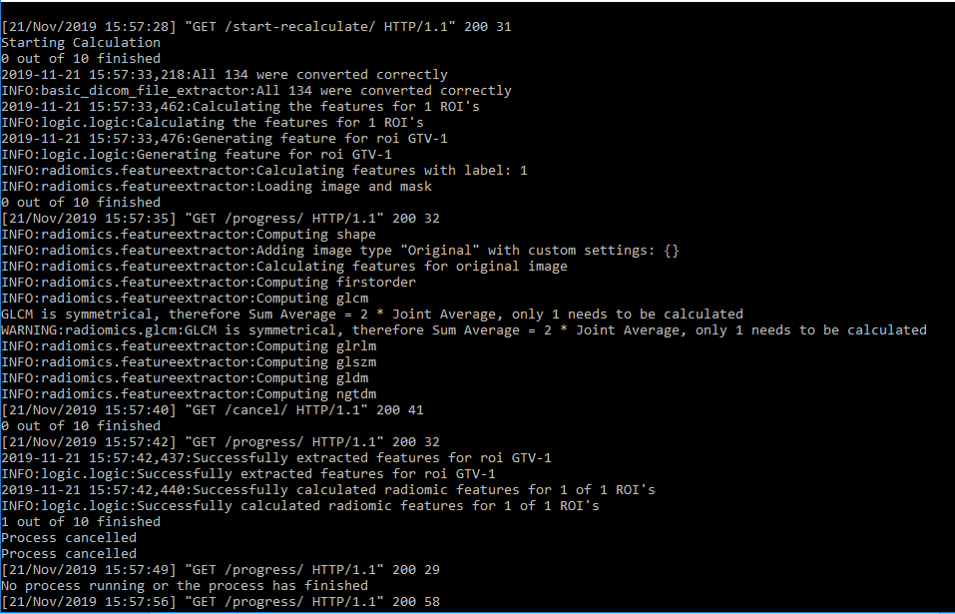

Example of how the terminal looks like during calculation.

WARNING: Do not close the terminal during a calculation! Wait for the calculation to either properly cancel (if you have cancelled), or let it run until the end. Risk of incomplete calculation data being stored or corruption of data!

## 4.2 Interface Layout

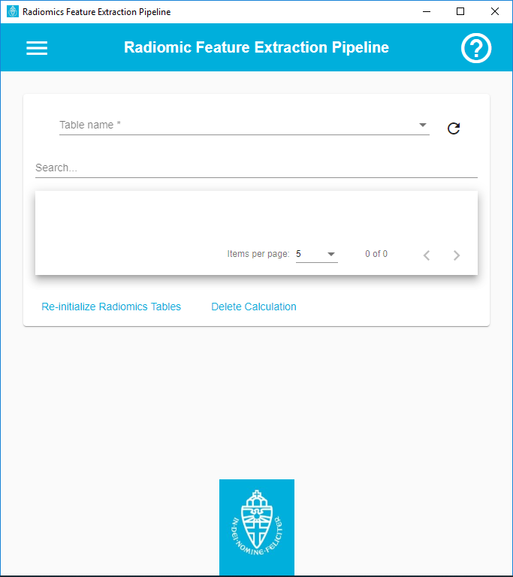

10

6

8

7

9

5

4

3

2

1

1. Menu: open to expand and view more options.
2. Help: click this to open a dialog with information regarding functionality of the tool.
3. Table Name: click to select a table to view.
4. Refresh: refreshes data.
5. Search: type in something to filter the viewed data.
6. Area where data is loaded as a table.
7. Item number: select to change the number of items displayed per page.
8. Pagination: scroll through the available pages
9. Re-initialize Radiomics Tables: allows for re-initialization of radiomics tables – NOTE: all data stored in those tables will be DELETED. This Deletes tables in the database and recreates them.
10. Delete Calculation: opens up calculations executed as options to delete.

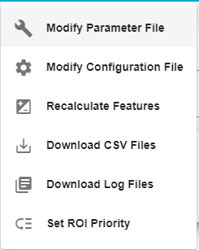

1. Modify Parameter File: opens a dialog where the contents of the parameter file are loaded and can be edited or restored.

16

15

14

13

12

11

1. Modify Configuration File: opens a dialog where the contents of the configuration file are loaded and can be edited or restored.
2. Recalculate Features: based on the settings (parameter file and configuration file), executes calculation on all currently stored data.
3. Download CSV Files: downloads any outputted csv files.
4. Download Log Files: downloads any available log files.
5. Set ROI Priority: opens a dialog with all regions of interest currently available and their priority value, which can be modified and saved.

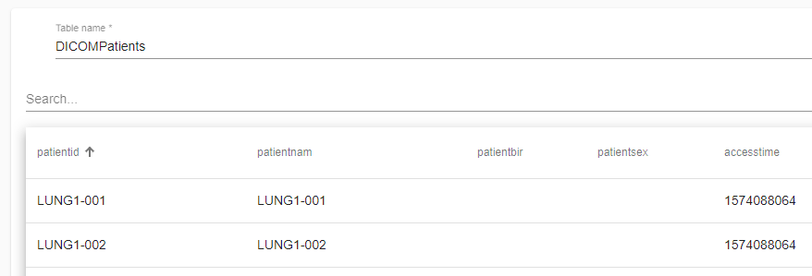

17

1. Sort: click to sort the column – ascending, descending or not sorted.

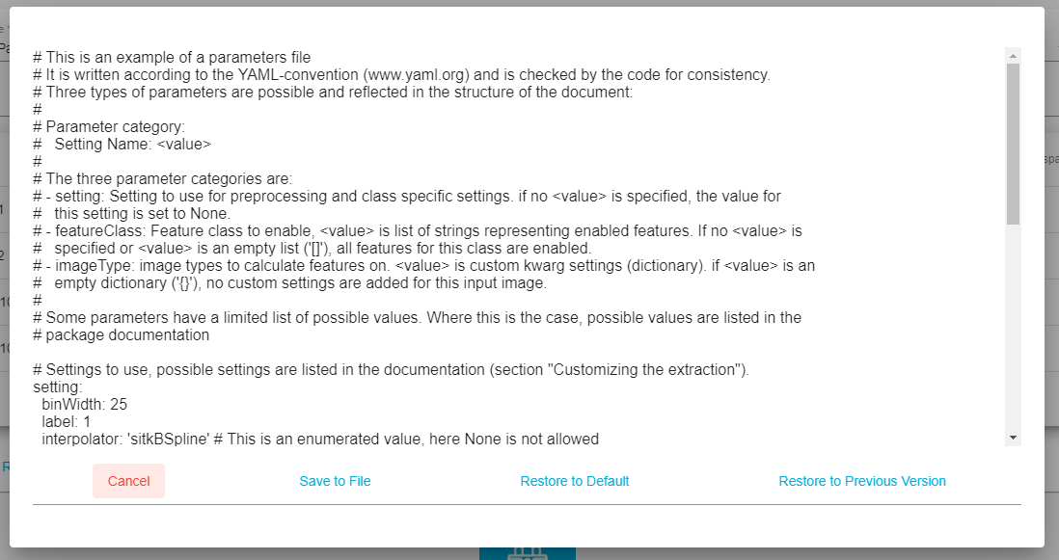

20

19

18

22

21

1. Text Area: area where the contents of either the parameter or the configuration file will be loaded into. This text can be modified.
2. Cancel: closes the dialog.
3. Save to File: saves the content found in 18 to the corresponding file it was opened from.
4. Restore to Default: restores the contents of the file to the default ones.
5. Restore to Previous Version: restores the contents of the file to the previously saved version.

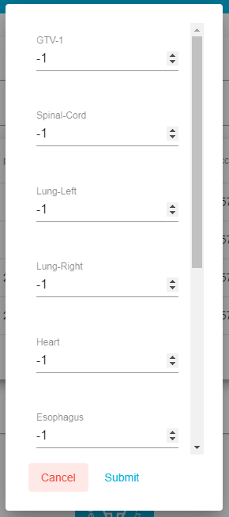

23

25

24

1. ROI Name
2. ROI priority value. If -1, then this ROI has not been given a priority yet.
3. Spinner: allows to increase of decrease the value of the priority. This value is between 1 and 10. 1 is the highest priority, 10 being the lowest.
4. Cancel: closes the dialog.
5. Submit: saves the values.

26

27

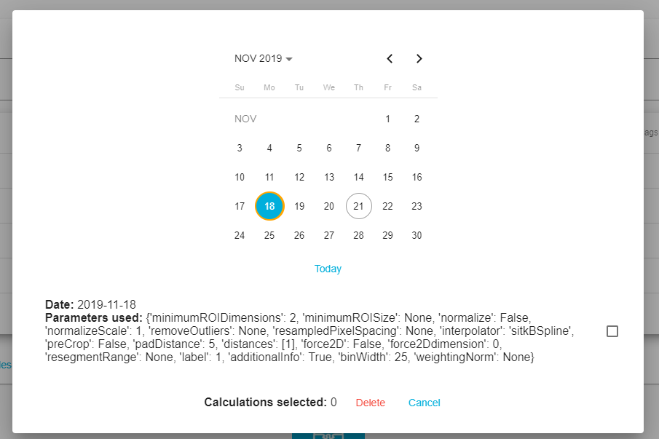

32

34

33

31

29

30

28

1. Allows to pick a year.
2. Allows to scroll between months
3. Blue circle: selected day. Orange circle: day with calculations. Grey outline circle: current day.
4. Today: goes back to current date.
5. List of calculations. These are selectable and deselectable.
6. Delete: deletes selected calculations.
7. Cancel: closes dialog.

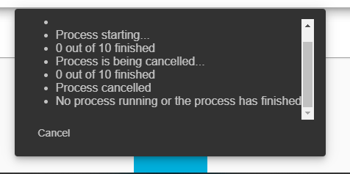

35

36

1. Message Area: area where messages are loaded during calculation process. If cancel is clicked, indication of such action will be seen in this area. The calculation for current RTStruct will finish before terminating the calculation process.
2. Cancel: issues a cancel command to the calculation process.

# 5. Troubleshooting

## 5.1 Python 2

If you have python 2.x installed, this could lead to some problems when setting up the tool. If you get any errors when running **Setup.bat**, please find your python installation, usually at (or something similar):

**C:\Users\username\AppData\Local\Programs\Python\Python36**

(note that username should be the name of the profile on your machine)

In this folder there is a **Python.exe** file. Make a copy of this file and rename it to **Python3.exe**

In the folder where the **Sqlite4Radiomics** is located, there is a **scripts** folder. Within, you can find a batch file named **venv-setup.bat**.

Open this file in edit mode and substitute the “py -3.6” with “python3”. Save and close the file. The **Setup.bat** file should now be able to run without any further complications.

## 5.2 Terminal Errors

If you modify the configuration file and something goes wrong, the terminal should show that an error has occurred. All that needs to be done is to restore your configuration file. This can be done either in the interface. If this doesn’t work, go to **backend -> resources -> backups** where you should find the default and previous versions of the files that can be modified. Copy the file you need into the **resources** folder, rename it to the correct name and delete the bad file.

If your problem is not related to the above-mentioned reasons, it is advised that you “re-install” the tool or contact an IT specialist at the department.

## 5.3 CSV and Logs

If you want to find your outputted csv files yourself instead of downloading them, these can be found in **backend -> out**. Similarly, log files can be found in **backend -> logs**.